Assignment 2: Introduction to PyTorch
CSC 592: Machine Learning Security and Privacy

Background

PyTorch is one of the most popular machine learning frameworks with an estimated 70% of AI research implementations using PyTorch in 2024 [1]. PyTorch's integration with GPU hardware allows for efficient large-scale parallel computations such as training machine learning models. In this assignment you will familiarize yourself with PyTorch and build a simple regression model using PyTorch.

Part 1: Installing PyTorch

The installation steps for PyTorch vary slightly depending on the operating system of your computer. For Linux and Mac users the following link gives the instructions for install PyTorch: https://pytorch.org/get-started/locally/

Part 2: Testing the PyTorch Installation

Testing to see if PyTorch is installed successfully:
This test assumes that you are using Visual Studio as your integrated development environment. You are free to use whichever software you want to code and develop in PyTorch, just note that the screenshots in the assignment may not exactly match your output if you are not using Visual Studio.

Step 2.1: Create a Visual Studio Python project called “PyTorchTest”.

Step 2.2: Change the Python environment to “pytorch2x” (or whatever is the name of your environment) by expanding the Python environments in the solution explorer. In the Visual Studio project, you will need to set the current environment to pytorch2x (. Right click on the Python environments and choose, “Add Environment”).

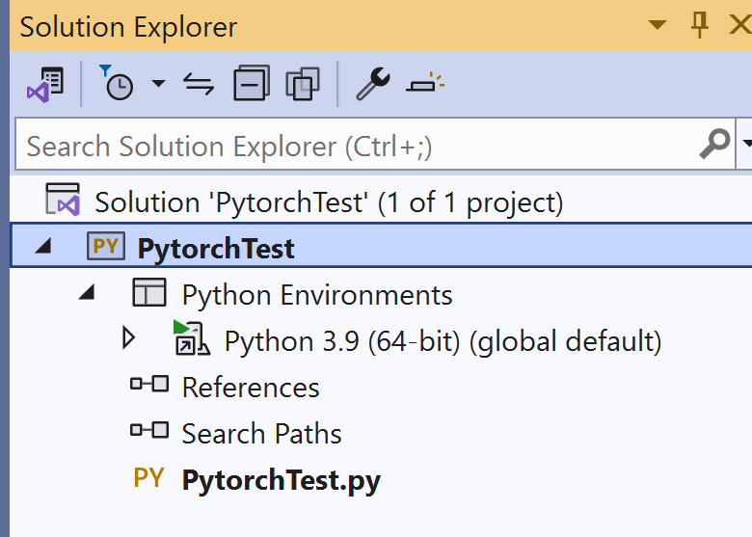
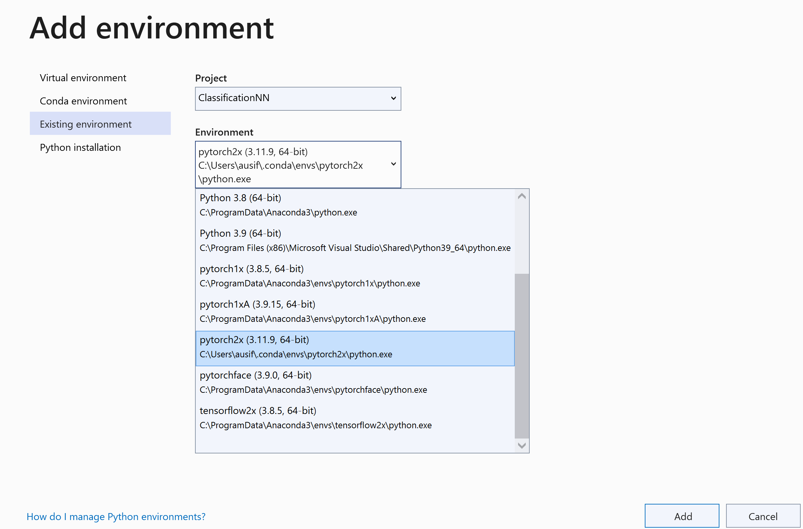

Step 2.3: The selected environment should show up as bold under the environments in Visual Studio as shown below:
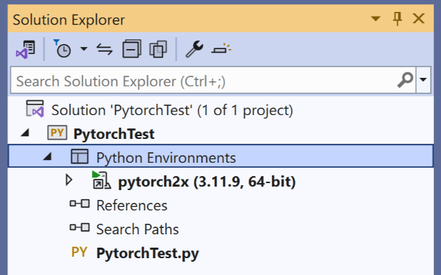
The default environment will be shown in bold.

Step 2.4: Type the following code in the PyTorchTest.py.

import sys
import numpy as np
import torch

def main():
x = np.arange(100)
#----------- use gpu if available else cpu------------
device = 'cuda' if torch.cuda.is_available() else 'cpu'
print('Pytorch will use: ', device)
#----convert numpy to tensor-----
x_tensor = torch.from_numpy(x).float().to(device)
print(type(x_tensor))

if __name__ == "__main__":
sys.exit(int(main() or 0))

Exercise 1: Run “PyTorchTest.py” and record the resulting output from your computer as a screenshot. If you have GPU available on your machine, the output will appear as:

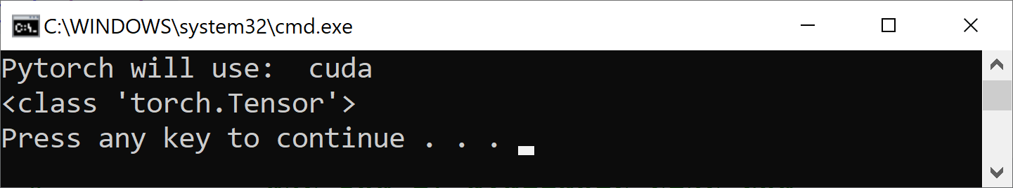

Otherwise, it will appear as:

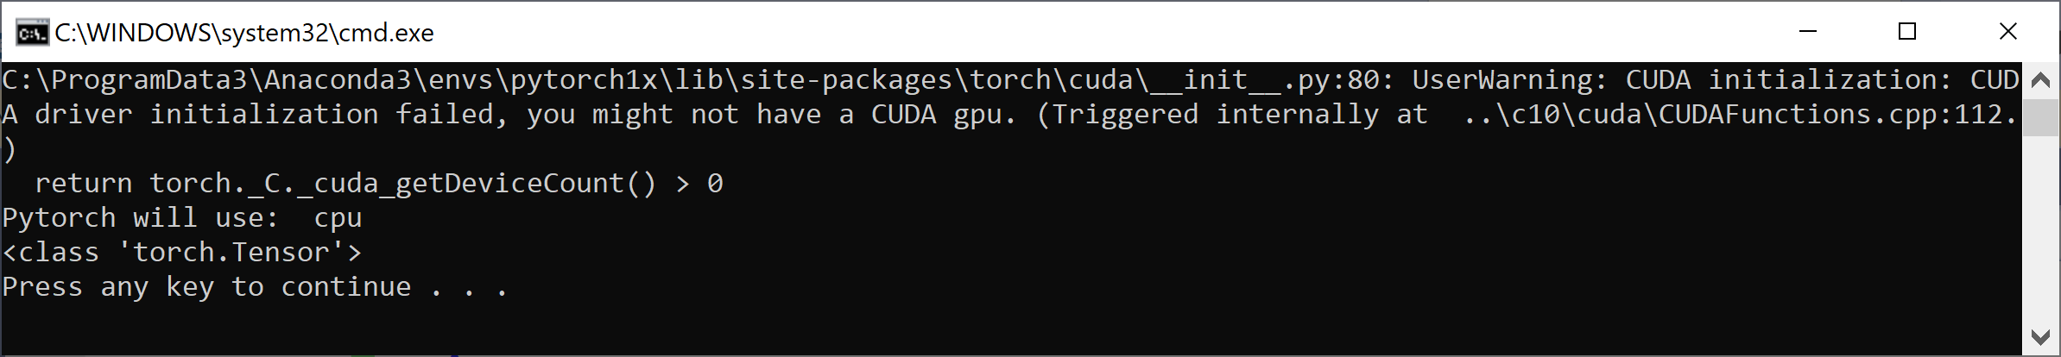

You can still use PyTorch even if you do not have a GPU. As you can see from the above test code, the typical code to determine if you have a GPU or not is:

device = 'cuda' if torch.cuda.is_available() else 'cpu'

The key concept in PyTorch is that the numpy arrays have to be to converted to PyTorch tensors, e.g.,

x = np.arange(100)
x_tensor = torch.from_numpy(x).float().to(device)

converts the numpy array x to x_tensor. The tensors will be computed on the CPU or the GPU.

To convert a tensor back to numpy:

x_cpu = x_tensor.cpu().numpy()

Part 3: Datasets and Dataloaders

An important concept in PyTorch is the concept of DataSet and DataLoader. The dataset is responsible for providing access to the training and/or test data. The DataLoader makes converts the data from the dataset to a tensor and puts it on the CPU or the GPU depending upon the GPU availability. The DataLoader is written to return a batch of data.

PyTorch provides a library called “AutoGrad” which computes the partial derivates of the loss function automatically for us. Further it provides a simple function to update the weights and biases. Typically, the following lines are used in the training loop.

model(x) # implicitly calls forward function
loss.backward() # compute gradients
optimizer.step() # update weights, biases
optimizer.zero_grad() # clear gradients

Let us create a simple single neuron network in PyTorch.

Step 3.1: Create a Python application project called “PyTorch1”.

Step 3.2: Add a class called “MyDataSet” to “PyTorch1” with the following code in it:

from torch.utils.data import Dataset, TensorDataset
import torch

class MyDataSet(Dataset):
def __init__(self, x_tensor, y_tensor):
self.x = x_tensor
self.y = y_tensor

def __getitem__(self, index):
return (self.x[index], self.y[index])

def __len__(self):
return len(self.x)

As you can see from the above code, the DataSet stores the x_tensor and the y_tensor and makes one item available to the caller via the getItem function.

Step 3.3: Add a class called “SimpleModel” to the project with the following code in it.

import torch

class SimpleModel(torch.nn.Module):
def __init__(self):
super().__init__()
self.w = torch.nn.Parameter(torch.randn(1, requires_grad=True, dtype=torch.float))
self.b = torch.nn.Parameter(torch.randn(1, requires_grad=True, dtype=torch.float))

def forward(self, x):
return self.w * x + self.b

The above code creates single neuron network with two learnable parameters w and b that are randomly initialized. The forward function computes the wx + b for the neuron. As you can see from the above code, the variables in PyTorch are declared as torch.nn.Parameter. The requires_grad=True indicates that the gradient of the loss with respect to this variable will be computed.

Step 3.4: Type the following code in the PyTorch1.py file. The following program first trains the simple model for learning the equation y = 2x + 0.4 without using a DataLoader. The second part of the program uses the DataLoader approach to train the single neuron network. Study the following code carefully to understand the PyTorch concepts:

import sys
import numpy as np
import torch
import random
from SimpleModel import SimpleModel
from MyDataSet import MyDataSet
from torch.utils.data import DataLoader
from torch.utils.data.dataset import random_split

def main():
x = np.arange(100)
#----------- use gpu if available else cpu------------
device = 'cuda' if torch.cuda.is_available() else 'cpu'

#----convert numpy to tensor-----
x_tensor = torch.from_numpy(x).float().to(device)
print(type(x_tensor))

#----convert tensor back to numpy
x_cpu = x_tensor.cpu().numpy() # first convert tensor to numpy
print(type(x_cpu))

#--requires_grad = True or False to make a variable trainable or not
w = torch.randn(1, requires_grad=True, dtype=torch.float).to(device)
b = torch.randn(1, requires_grad=True, dtype=torch.float).to(device)
print(w)

# We can either create regular tensors and send them to the device
a = torch.randn(1, dtype=torch.float).to(device)
b = torch.randn(1, dtype=torch.float).to(device)
# and THEN set them as requiring gradients...
a.requires_grad_()
b.requires_grad_(False)
print(a)
print(b)
# We can specify the device at the moment of creation - RECOMMENDED!
torch.manual_seed(42)
a = torch.randn(1, requires_grad=True, dtype=torch.float, device=device)
b = torch.randn(1, requires_grad=True, dtype=torch.float, device=device)
print(a)
print(b)
# methods that end with _ do inplace modification
# loss.bakward() to compute gradients
# .zero_() to zero out gradients
# .grad attribute to examine the value of the gradient for a given tensor

w = torch.randn(1, requires_grad=True, dtype=torch.float, device=device)
b = torch.randn(1, requires_grad=True, dtype=torch.float, device=device)

lr = 1e-2
n_epochs = 1000

# Defines a MSE loss function
x_train = np.arange(0,10)
y_train = x_train * 2 + 0.4 # y = 2x + 0.4

x_train_tensor = torch.from_numpy(x_train).float().to(device)
y_train_tensor = torch.from_numpy(y_train).float().to(device)

loss_fn = torch.nn.MSELoss(reduction='mean')
model = SimpleModel().to(device)
model.train() # set the model in train mode
# optimizer = torch.optim.SGD([w, b], lr=lr)
optimizer = torch.optim.SGD(model.parameters(), lr=lr)

for epoch in range(n_epochs):
#aout = w * x_train_tensor + b
aout = model(x_train_tensor)
loss = loss_fn(y_train_tensor, aout)

loss.backward() # compute gradients
optimizer.step() # update weights, biases
optimizer.zero_grad() # clear gradients
#print(w)
#print(b)
print(model.state_dict()) # model's weights and parameters

#--------------DataLoader version-------------------
x_train = np.arange(0,10)
y_train = x_train * 2 + 0.4 # y = 2x + 0.4
# without.to(device), it is a CPU Tensor
x_train_tensor = torch.from_numpy(x_train).float()
y_train_tensor = torch.from_numpy(y_train).float()
mydataset = MyDataSet(x_train_tensor, y_train_tensor)
train_dataset, val_dataset = random_split(mydataset, [8, 2])

train_loader = DataLoader(dataset=train_dataset, batch_size=4)
val_loader = DataLoader(dataset=val_dataset, batch_size=2)
print(train_dataset[0])
#train_loader = DataLoader(dataset=train_dataset, batch_size=4, shuffle=True)

losses = []
val_losses = []
lr = 1e-2
n_epochs = 100
loss_fn = torch.nn.MSELoss(reduction='mean')
model = SimpleModel().to(device)
model.train() # set the model in train mode
# optimizer = torch.optim.SGD([w, b], lr=lr)
optimizer = torch.optim.SGD(model.parameters(), lr=lr)

for epoch in range(n_epochs):
for x_batch, y_batch in train_loader:
x_batch = x_batch.to(device) # load data in GPU
y_batch = y_batch.to(device)
aout = model(x_batch)
loss = loss_fn(y_batch, aout)

loss.backward() # compute gradients
optimizer.step() # update weights, biases
optimizer.zero_grad() # clear gradients
losses.append(loss)
with torch.no_grad(): # turn of gradient calculation
for x_val, y_val in val_loader:
x_val = x_val.to(device)
y_val = y_val.to(device)
model.eval() # set model to evaluation mode

aout = model(x_val)
val_loss = loss_fn(y_val, aout)
val_losses.append(val_loss.item())
print('epoch' + str(epoch) + ' validation loss = ' + str(val_loss))
print(model.state_dict())

if __name__ == "__main__":
sys.exit(int(main() or 0))

Exercise 2: Run the PyTorch1.py file and record a screenshot of the output. If you run the program, the output should appear as shown below. Note depending on your version of PyTorch the output may vary slightly which is fine:

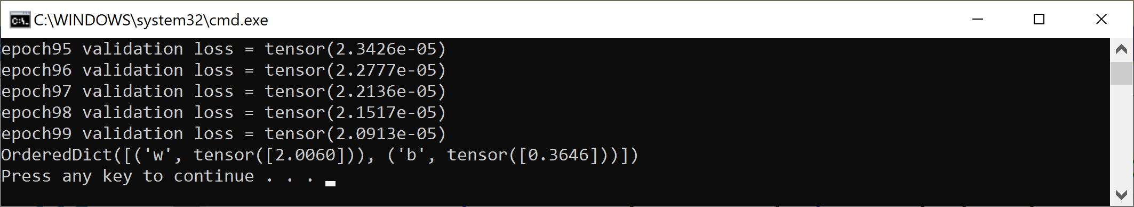

Answer the following questions and include it along with your screenshot for Exercise 2:

Exercise 2 Question A: How many epochs is the model trained for?
Exercise 2 Question B: Is the loss function in this code mean square error or cross entropy?
Exercise 2 Question C: Why is it important to evaluate the validation loss during training?
Exercise 2 Question D: How many trainable parameters does the simple model have?
Exercise 2 Question E: In this training algorithm is full batch, mini-batch or stochastic gradient descent being used? Hint: This does not depend on the optimizer in the code but rather the batch size of the dataloader.

Part 4: Learning Regression in Numpy

If the predicted output from a network is expected to be a numeric value indicating some output value (as opposed to indicating the class of the output), the problem is referred to as regression problem. Suppose, we wanted to approximate a Sine function from –pi to pi by a third degree polynomial as:

y = sin(x)
approximated with:

y = a x³ + bx² + cx + d

The goal is to determine the appropriate values of a, b, c and d. The inputs to the system are x, x², and x³

Step 4.1: Create a new Python application called FunctionApproximation.py.

To be able to visualize the approximation of the sine wave by the polynomial, we will add a plotting function to the project.

Step 4.2: Add a file called Utils.py with the following code in it:

from numpy import *
import matplotlib.pyplot as plt

def plot_predicted_vs_actual(ypred, yactual):
mean_abs_error = sum(abs(ypred-yactual))/len(ypred)
step_size = 20 # plot every 20th point
a_pred = [ypred[i] for i in range(0,len(ypred)) if i%step_size==0]
b_actual = [yactual[i] for i in range(0,len(ypred)) if i%step_size==0]
t = linspace(0, len(a_pred), len(a_pred))
plt.plot(t,a_pred, 'red',linestyle='dashed', label='predicted')
plt.plot(t,b_actual,'blue', label='actual')
plt.scatter(t,a_pred,marker='o',s=10, color='red', label='predicted')
plt.scatter(t,b_actual,marker='o',s=10, color='blue', label='actual')
plt.legend()
plt.title('mean absolute error = '+ str(mean_abs_error))
plt.show()

Step 4.3: Add a file to the project called “FunctionApprox.py” with the following code in it. The first version uses just Numpy to determine the a, b, c, and d values. Note that we are computing the gradients of the loss with respect to each variable ourselves. For example, the gradient of y_pred with respect to a is x**3.

import sys
import numpy as np
import math
import Utils

def main():
# Create random input and output data
x = np.linspace(-math.pi, math.pi, 2000)
y = np.sin(x)

# randomly initialize weights
a = np.random.randn()
b = np.random.randn()
c = np.random.randn()
d = np.random.randn()

learning_rate = 1e-6
for t in range(2000):
# Forward pass: compute predicted y
# y = a x^3+ b x^2 + c x + d
y_pred = a * x** 3 + b * x**2 + c * x + d

# Compute and print loss
loss = np.square(y_pred - y).sum()
if t % 100 == 99:
print(t, loss)

# Backprop to compute gradients of a, b, c, d with respect to loss
grad_y_pred = 2.0 * (y_pred - y)
grad_d = grad_y_pred.sum()
grad_c = (grad_y_pred * x).sum()
grad_b = (grad_y_pred * x ** 2).sum()
grad_a = (grad_y_pred * x ** 3).sum()

# Update weights
a -= learning_rate * grad_a
b -= learning_rate * grad_b
c -= learning_rate * grad_c
d -= learning_rate * grad_d

print(f'Result: y = {a} x^3+ {b} x^2 + {c} x + {d}')

y_pred = a * x** 3 + b * x**2 + c * x + d
Utils.plot_predicted_vs_actual(y_pred, y)

if __name__ == "__main__":
sys.exit(int(main() or 0))

Exercise 3: Run the FunctionApprox.py and file and record a screenshot of the output. If you run the program, the output should appear similar as to what is shown below:

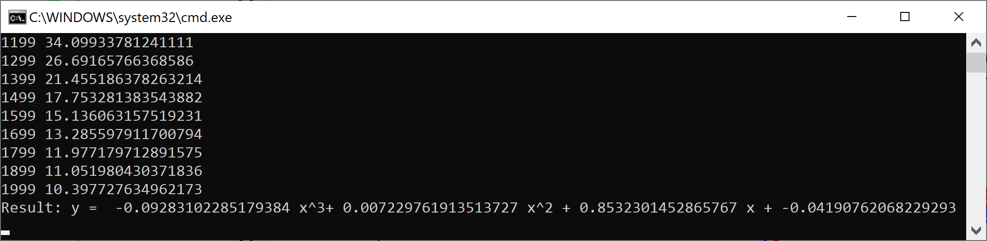

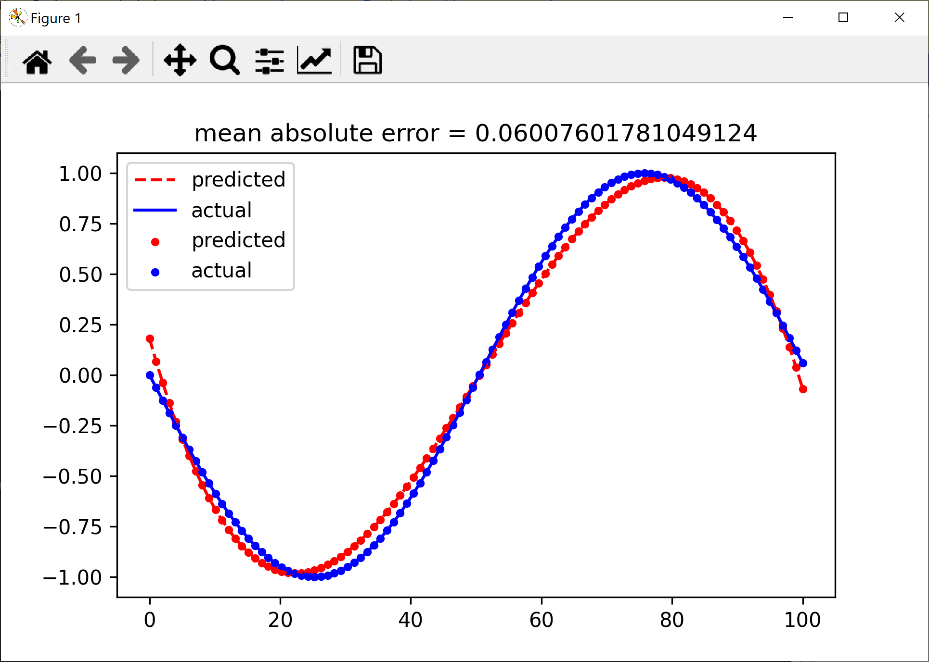

Part 5: Learning Regression in PyTorch (without AutoGrad)

Step 5.1: Add a file called “FunctionApproxPyTorch.py” to the existing project with the following code in it. This version uses PyTorch tensors. To be able to visualize the predicted output vs the actual sine wave, we need to detach the tensor and convert it to Numpy (see the lines towards the end of the following code):

import sys
import torch
import math
import Utils

def main():
dtype = torch.float
device = torch.device("cpu")
# device = torch.device("cuda:0") # Uncomment this to run on GPU

# Create random input and output data
x = torch.linspace(-math.pi, math.pi, 2000, device=device, dtype=dtype)
y = torch.sin(x)

# Randomly initialize weights
a = torch.randn((), device=device, dtype=dtype)
b = torch.randn((), device=device, dtype=dtype)
c = torch.randn((), device=device, dtype=dtype)
d = torch.randn((), device=device, dtype=dtype)

learning_rate = 1e-6
for t in range(2000):
# Forward pass: compute predicted y
y_pred = a * x** 3 + b * x**2 + c * x + d

# Compute and print loss
loss = (y_pred - y).pow(2).sum().item()
if t % 100 == 99:
print(t, loss)

# Backprop to compute gradients of a, b, c, d with respect to loss
grad_y_pred = 2.0 * (y_pred - y)
grad_d = grad_y_pred.sum()
grad_c = (grad_y_pred * x).sum()
grad_b = (grad_y_pred * x ** 2).sum()
grad_a = (grad_y_pred * x ** 3).sum()

# Update weights using gradient descent
a -= learning_rate * grad_a
b -= learning_rate * grad_b
c -= learning_rate * grad_c
d -= learning_rate * grad_d

print(f'Result: y = {a.item()}x^3 + {b.item()} x^2 + {c.item()} x + {d.item()} ')

y_pred = a * x** 3 + b * x**2 + c * x + d

# visualize the results, first convert y, y_pred to numpy
y_pred = y_pred.detach().numpy()
y = y.detach().numpy()
Utils.plot_predicted_vs_actual(y_pred, y)

if __name__ == "__main__":
sys.exit(int(main() or 0))

Exercise 4: Set the “FunctionApproxPyTorch.py “as the start file and run the program. Record the output. Your program should output something similar to the following:

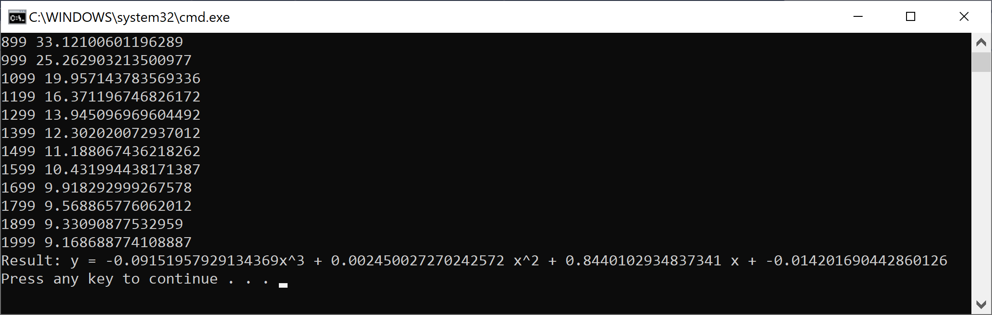

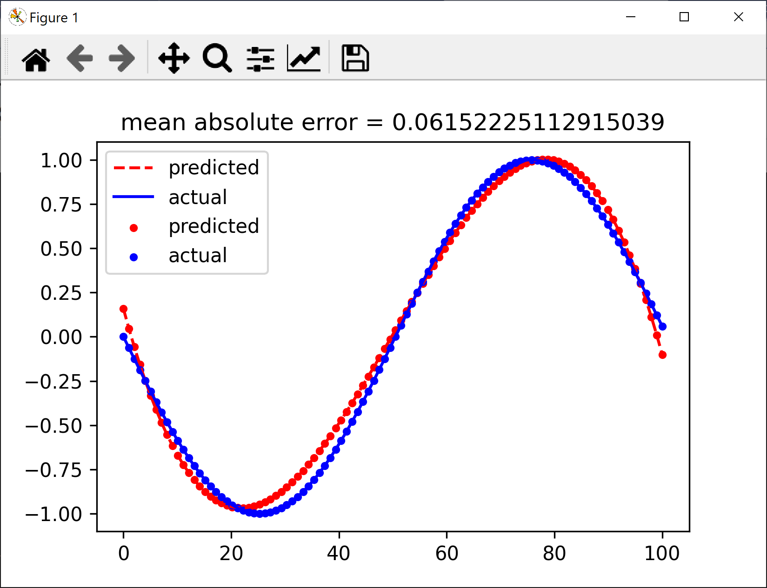

Part 6: Learning Regression in PyTorch (with AutoGrad)

Previously, we computed the gradients manually. PyTorch’s AutoGrad can compute the gradients automatically for us. We will show how to do automatic differentiation in this version of the program.

Step 6.1: Add a file called “FunctionApproxAutoGrad.py” with the following code in it.

import sys
import torch
import math
import Utils

def main():
dtype = torch.float
device = torch.device("cpu")
# device = torch.device("cuda:0") # Uncomment this to run on GPU

# Create Tensors to hold input and outputs.
# By default, requires_grad=False, which indicates that we do not need to
# compute gradients with respect to these Tensors during the backward pass.
x = torch.linspace(-math.pi, math.pi, 2000, device=device, dtype=dtype)
y = torch.sin(x)

# Create random Tensors for weights. For a third order polynomial, we need
# 4 weights: y = ax^3 + bx^2 + c x + d
# Setting requires_grad=True indicates that we want to compute gradients with
# respect to these Tensors during the backward pass.
a = torch.randn((), device=device, dtype=dtype, requires_grad=True)
b = torch.randn((), device=device, dtype=dtype, requires_grad=True)
c = torch.randn((), device=device, dtype=dtype, requires_grad=True)
d = torch.randn((), device=device, dtype=dtype, requires_grad=True)

learning_rate = 1e-6
for t in range(2000):
# Forward pass: compute predicted y using operations on Tensors.
y_pred = a * x** 3 + b * x**2 + c * x + d

# Compute and print loss using operations on Tensors.
# Now loss is a Tensor of shape (1,)
# loss.item() gets the scalar value held in the loss.
loss = (y_pred - y).pow(2).sum()
if t % 100 == 99:
print(t, loss.item())

# Use autograd to compute the backward pass. This call will compute the
# gradient of loss with respect to all Tensors with requires_grad=True.
# After this call a.grad, b.grad. c.grad and d.grad will be Tensors holding
# the gradient of the loss with respect to a, b, c, d respectively.
loss.backward()

# Manually update weights using gradient descent. Wrap in torch.no_grad()
# because weights have requires_grad=True, but we don't need to track this
# in autograd.
with torch.no_grad():
a -= learning_rate * a.grad
b -= learning_rate * b.grad
c -= learning_rate * c.grad
d -= learning_rate * d.grad

# Manually zero the gradients after updating weights
a.grad = None
b.grad = None
c.grad = None
d.grad = None

print(f'Result: y = {a.item()}x^3 + {b.item()} x^2 + {c.item()} x + {d.item()}')
# visualize the results, first convert y, y_pred to numpy
y_pred = y_pred.detach().numpy()
y = y.detach().numpy()
Utils.plot_predicted_vs_actual(y_pred, y)

if __name__ == "__main__":
sys.exit(int(main() or 0))

Exercise 5: Set the “FunctionApproxAutoGrad.py “as the start file and run the program. Record the output. Your program should output something similar to the following:

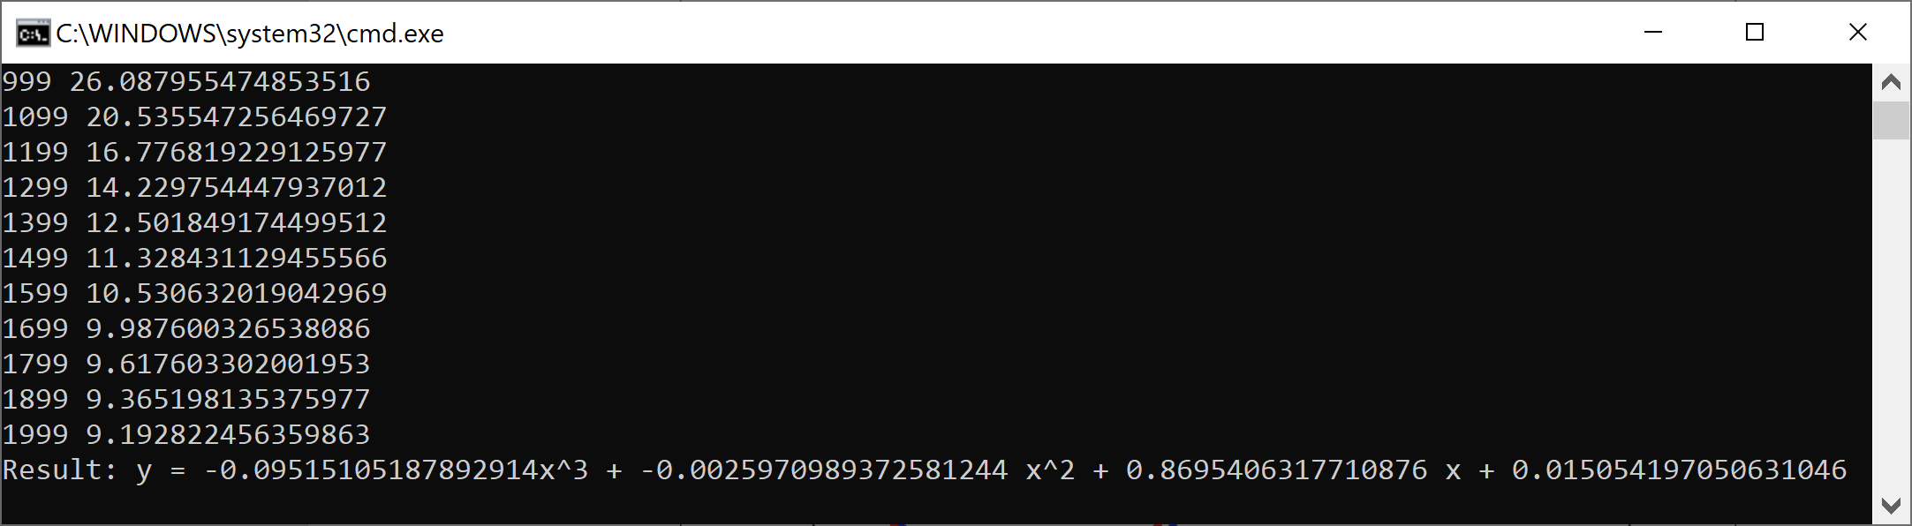

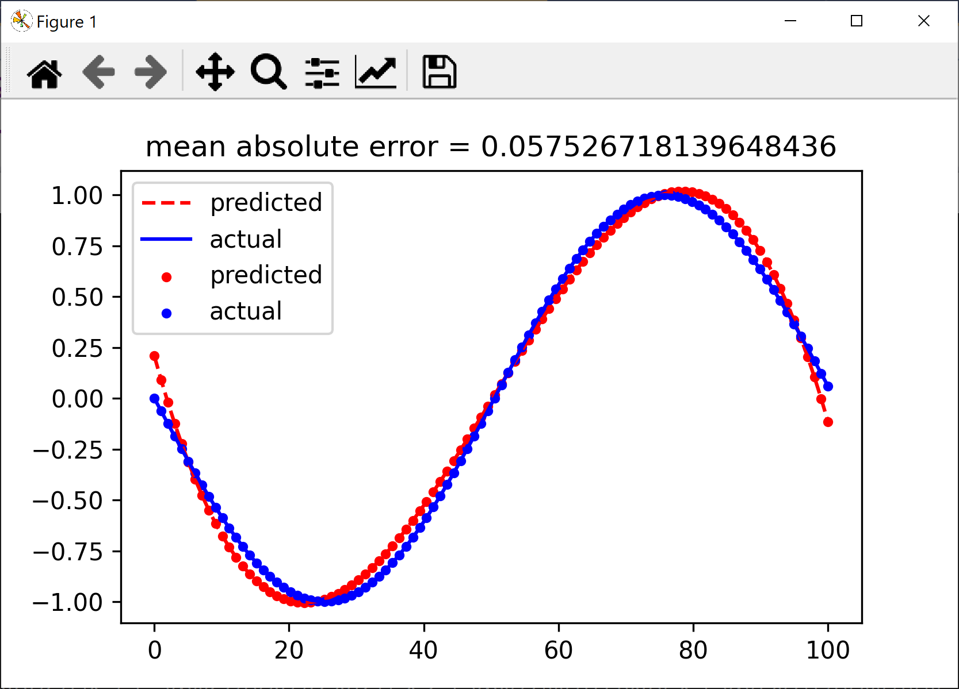

Part 7: Learning Regression with a Neural Network

Step 7.1: Add a file called “FunctionApproxNN.py”. In this example, three neurons are used in the hidden layer. The values of $x$, $x^{2}$, and $x^{3}$ are passed to the neural network. In this version, the network parameters are updated explicitly:

Import sys
import torch
import math
import Utils

def main():
# Create Tensors to hold input and outputs.
X = torch.linspace(-math.pi, math.pi, 2000)
y = torch.sin(x)

# For this example, the output y is a linear function of (x, x^2, x^3), so
# we can consider it as a linear layer neural network. Let’s prepare the
# tensor (x, x^2, x^3).
P = torch.tensor([1, 2, 3])
xx = x.unsqueeze(-1).pow(p)

# In the above code, x.unsqueeze(-1) has shape (2000, 1), and p has shape
# (3,), for this case, broadcasting semantics will apply to obtain a tensor
# of shape (2000, 3)

# Use the nn package to define our model as a sequence of layers. Nn.Sequential
# is a Module which contains other Modules, and applies them in sequence to
# produce its output. The Linear Module computes output from input using a
# linear function, and holds internal Tensors for its weight and bias.
# The Flatten layer lattens the output of the linear layer to a 1D tensor,
# to match the shape of `y`.
model = torch.nn.Sequential(
torch.nn.Linear(3, 1),
torch.nn.Flatten(0, 1)
)

# The nn package also contains definitions of popular loss functions; in this
# case we will use Mean Squared Error (MSE) as our loss function.
Loss_fn = torch.nn.MSELoss(reduction=’sum’)

learning_rate = 1e-6
for t in range(2000):

# Forward pass: compute predicted y by passing x to the model. Module objects
# override the __call__ operator so you can call them like functions. When
# doing so you pass a Tensor of input data to the Module and it produces
# a Tensor of output data.
Y_pred = model(xx)

# Compute and print loss. We pass Tensors containing the predicted and true
# values of y, and the loss function returns a Tensor containing the
# loss.
Loss = loss_fn(y_pred, y)
if t % 100 == 99:
print(t, loss.item())

# Zero the gradients before running the backward pass.
Model.zero_grad()

# Backward pass: compute gradient of the loss with respect to all the learnable
# parameters of the model. Internally, the parameters of each Module are stored
# in Tensors with requires_grad=True, so this call will compute gradients for
# all learnable parameters in the model.
Loss.backward()

# Update the weights using gradient descent. Each parameter is a Tensor, so
# we can access its gradients like we did before.
With torch.no_grad():
for param in model.parameters():
param -= learning_rate * param.grad

# You can access the first layer of `model` like accessing the first item of a list
linear_layer = model[0]

# For linear layer, its parameters are stored as `weight` and `bias`.
Print(f’Result: y = {linear_layer.bias.item()} + {linear_layer.weight[:, 0].item()} x + {linear_layer.weight[:, 1].item()} x^2 + {linear_layer.weight[:, 2].item()} x^3’)
y_pred = model(xx)
y_pred = y_pred.detach().numpy()
y = y.detach().numpy()
Utils.plot_predicted_vs_actual(y_pred, y)

if __name__ == “__main__”:
sys.exit(int(main() or 0))

Exercise 6: Set the “FunctionApproxNN.py “as the start file and run the program. Record the output. Your program should output something similar to the following:

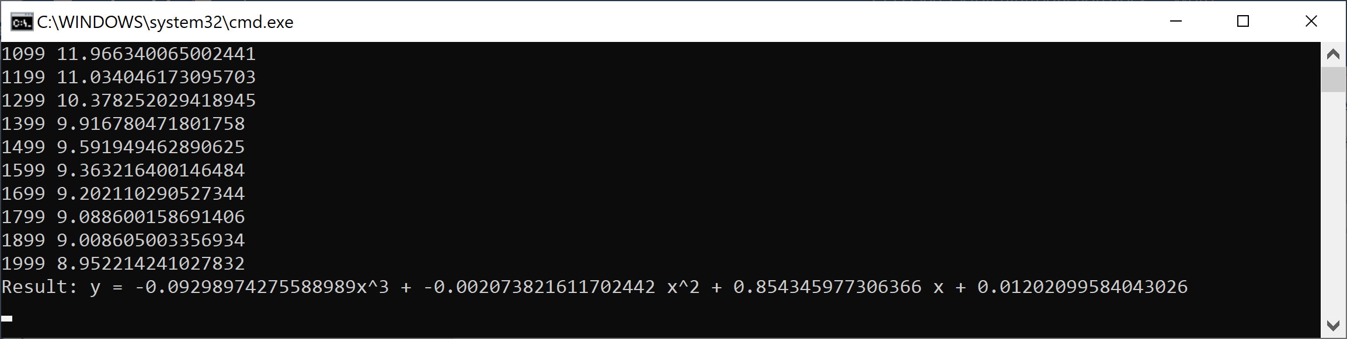

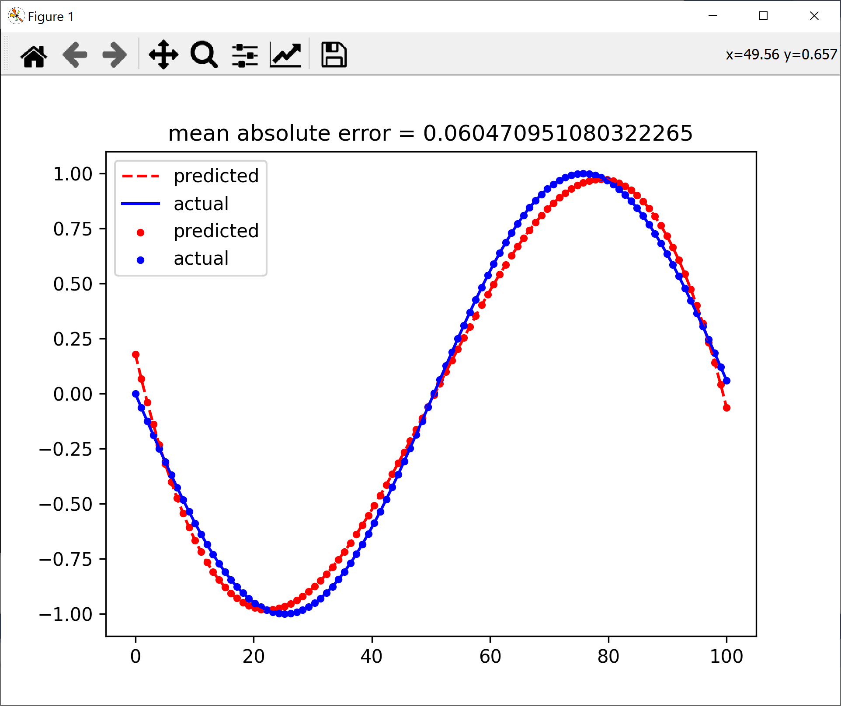

Part 8: Learning Regression with a Neural Network (single input)

One of the fundamental ideas in deep learning is to have our machine learning model handle all parts of the data processing if feasible. For example, for image classification this means feeding the entire image to the model as input. This is opposed to a more classical machine learning approach where instead features would be extracted from the image and the extracted features would be the input to the model.

Step 8.1: Instead of us computing of $x$, $x^{2}$, and $x^{3}$ values, we would like to simply pass $x$ to the network and have the network learn the Sine function. Add a file called “FunctionApproxNNDirect.py” with the following code in it:

import sys
import torch
import math
import Utils

def main():
# Create Tensors to hold input and outputs.
x = torch.linspace(-math.pi, math.pi, 2000)
y = torch.sin(x)

xx = x.reshape(len(x),1)

# Use the nn package to define our model as a sequence of layers. nn.Sequential
# is a Module which contains other Modules, and applies them in sequence to
# produce its output. The Linear Module computes output from input using a
# linear function, and holds internal Tensors for its weight and bias.
# The Flatten layer flatens the output of the linear layer to a 1D tensor,
# to match the shape of y.
model = torch.nn.Sequential(
torch.nn.Linear(1, 5),
torch.nn.Tanh(),
torch.nn.Linear(5, 1),
torch.nn.Tanh(),
torch.nn.Flatten(0, 1)
)

# The nn package also contains definitions of popular loss functions; in this
# case we will use Mean Squared Error (MSE) as our loss function.
loss_fn = torch.nn.MSELoss(reduction='sum')

learning_rate = 0.0001#1e-6
for t in range(20000):

# Forward pass: compute predicted y by passing x to the model. Module objects
# override the __call__ operator so you can call them like functions. When
# doing so you pass a Tensor of input data to the Module and it produces
# a Tensor of output data.
y_pred = model(xx)

# Compute and print loss. We pass Tensors containing the predicted and true
# values of y, and the loss function returns a Tensor containing the loss.
loss = loss_fn(y_pred, y)
if t % 100 == 99:
print(t, loss.item())

# Zero the gradients before running the backward pass.
model.zero_grad()

# Backward: compute gradient of the loss with respect to all the learnable
# parameters of the model. The parameters of each Module are stored
# in Tensors with requires_grad=True, so this call will compute gradients for
# all learnable parameters in the model.
loss.backward()

# Update the weights using gradient descent. Each parameter is a Tensor, so
# we can access its gradients like we did before.
with torch.no_grad():
for param in model.parameters():
param -= learning_rate * param.grad

# You can access the first layer of model as model[0]
linear_layer = model[0]

y_pred = model(xx)
y_pred = y_pred.detach().numpy()
y = y.detach().numpy()
Utils.plot_predicted_vs_actual(y_pred, y)

if __name__ == "__main__":
sys.exit(int(main() or 0))

Exercise 7: Set the “FunctionApproxNNDirect.py “as the start file and run the program. Notice that the activation function used in the network is tanh. Record the output. Your program should output something similar to the following:

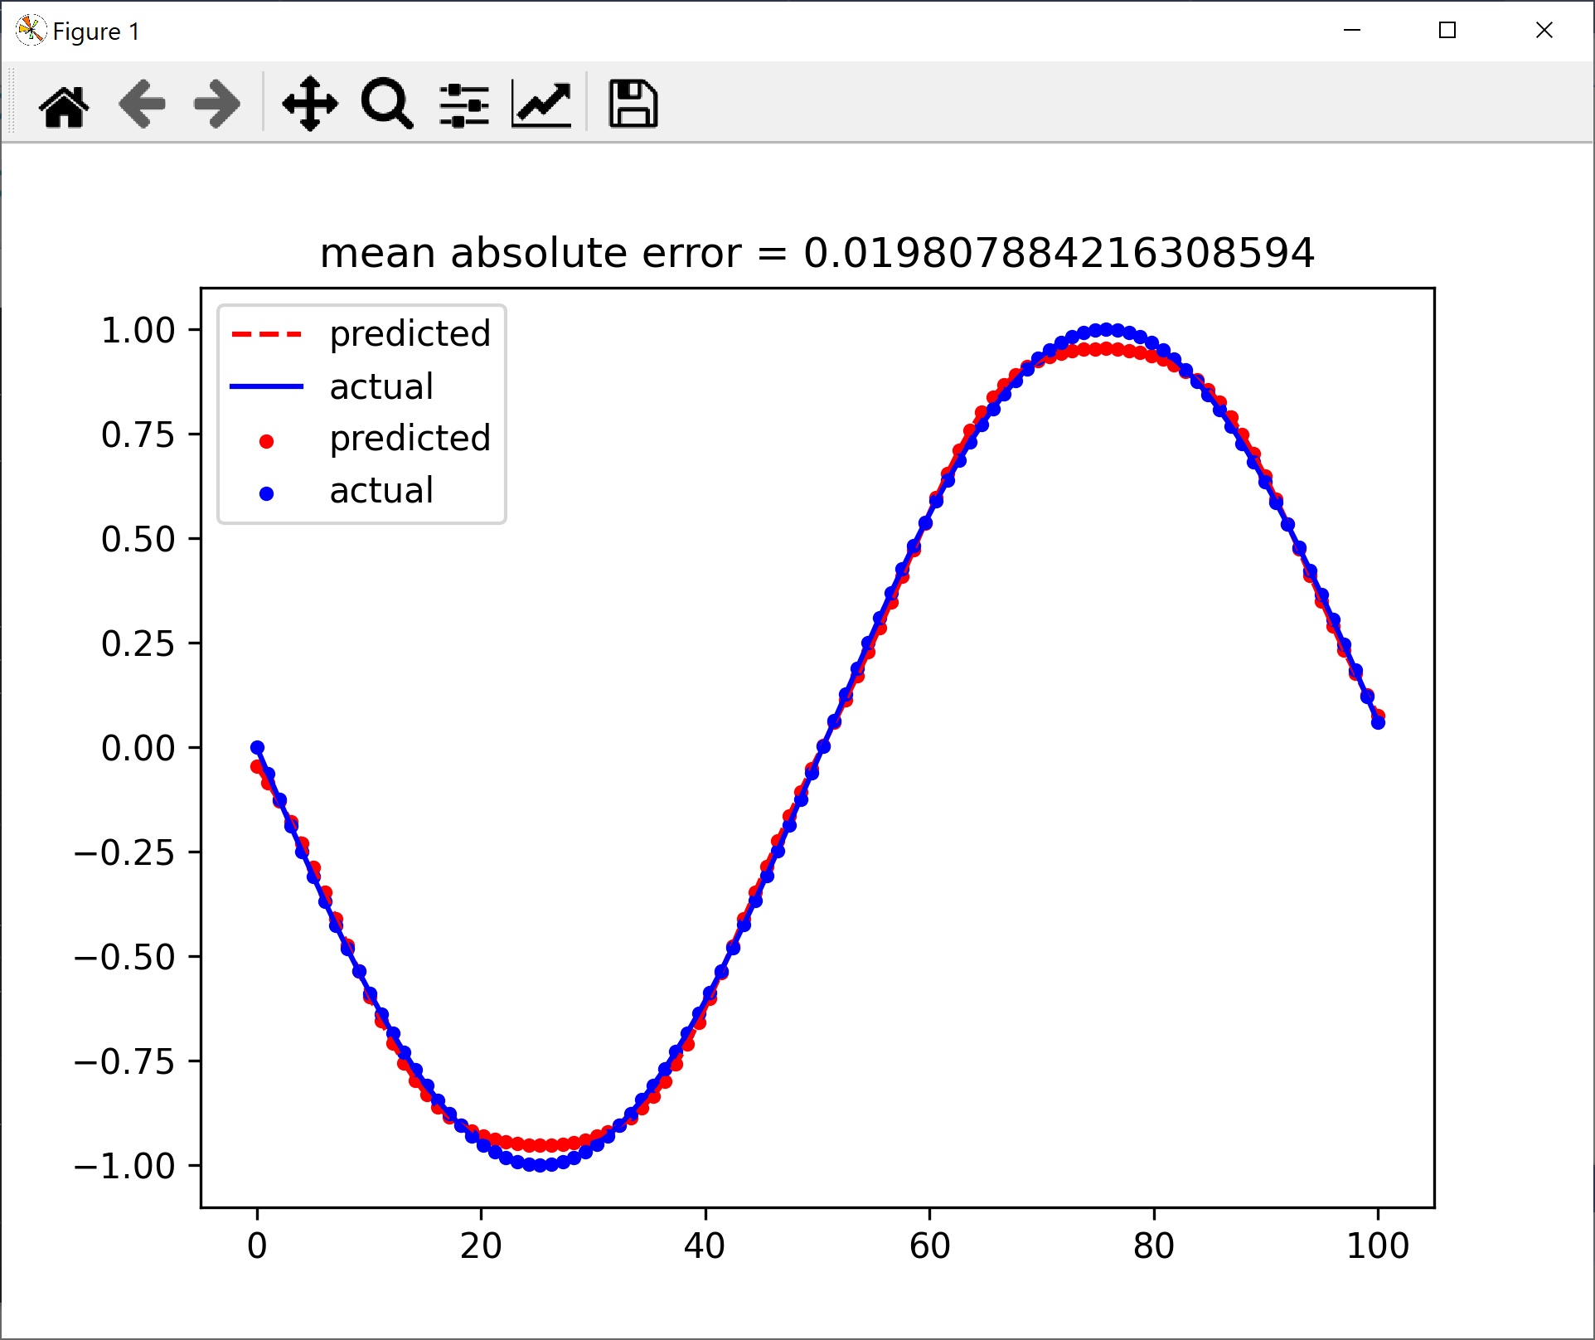
Exercise 8: Make the following changes to the code for each of the questions and run the code. Answer the associated questions and include the answers them along with a screenshot of your code’s output.

Exercise 8 Part A: Replace both instances of torch.nn.Tanh(), with torch.nn.ReLU() in the model. Run the code and record the output (which should look similar to what is shown below). Why is the model not able to reproduce the values from $x=0$ to $x=40$? Hint: You may need to read up on the ReLu activation function.

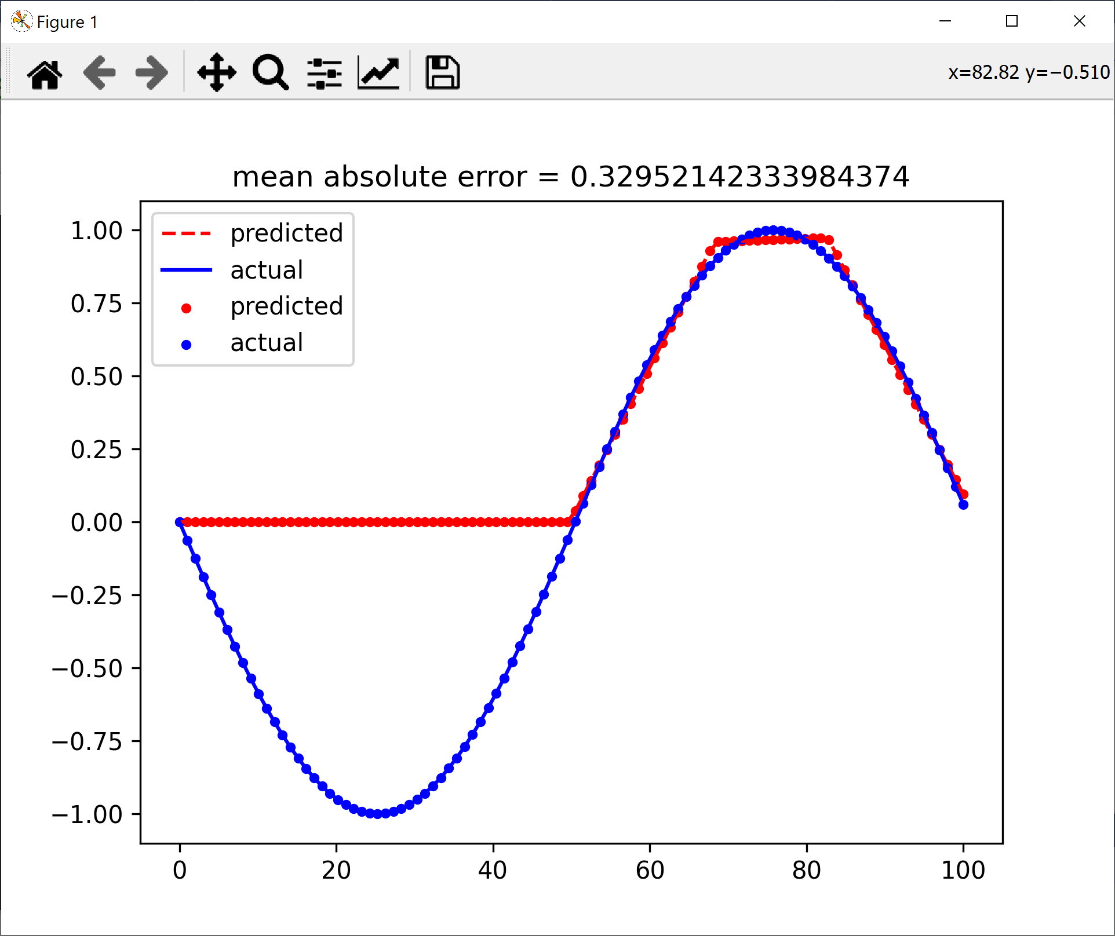

Exercise 8 Part B: Replace both instances of torch.nn.Tanh(), with torch.nn.Sigmoid(). Run the code and record the output (which should look similar to what is shown below). Why is the model not able to reproduce the values from $x=0$ to $x=40$?

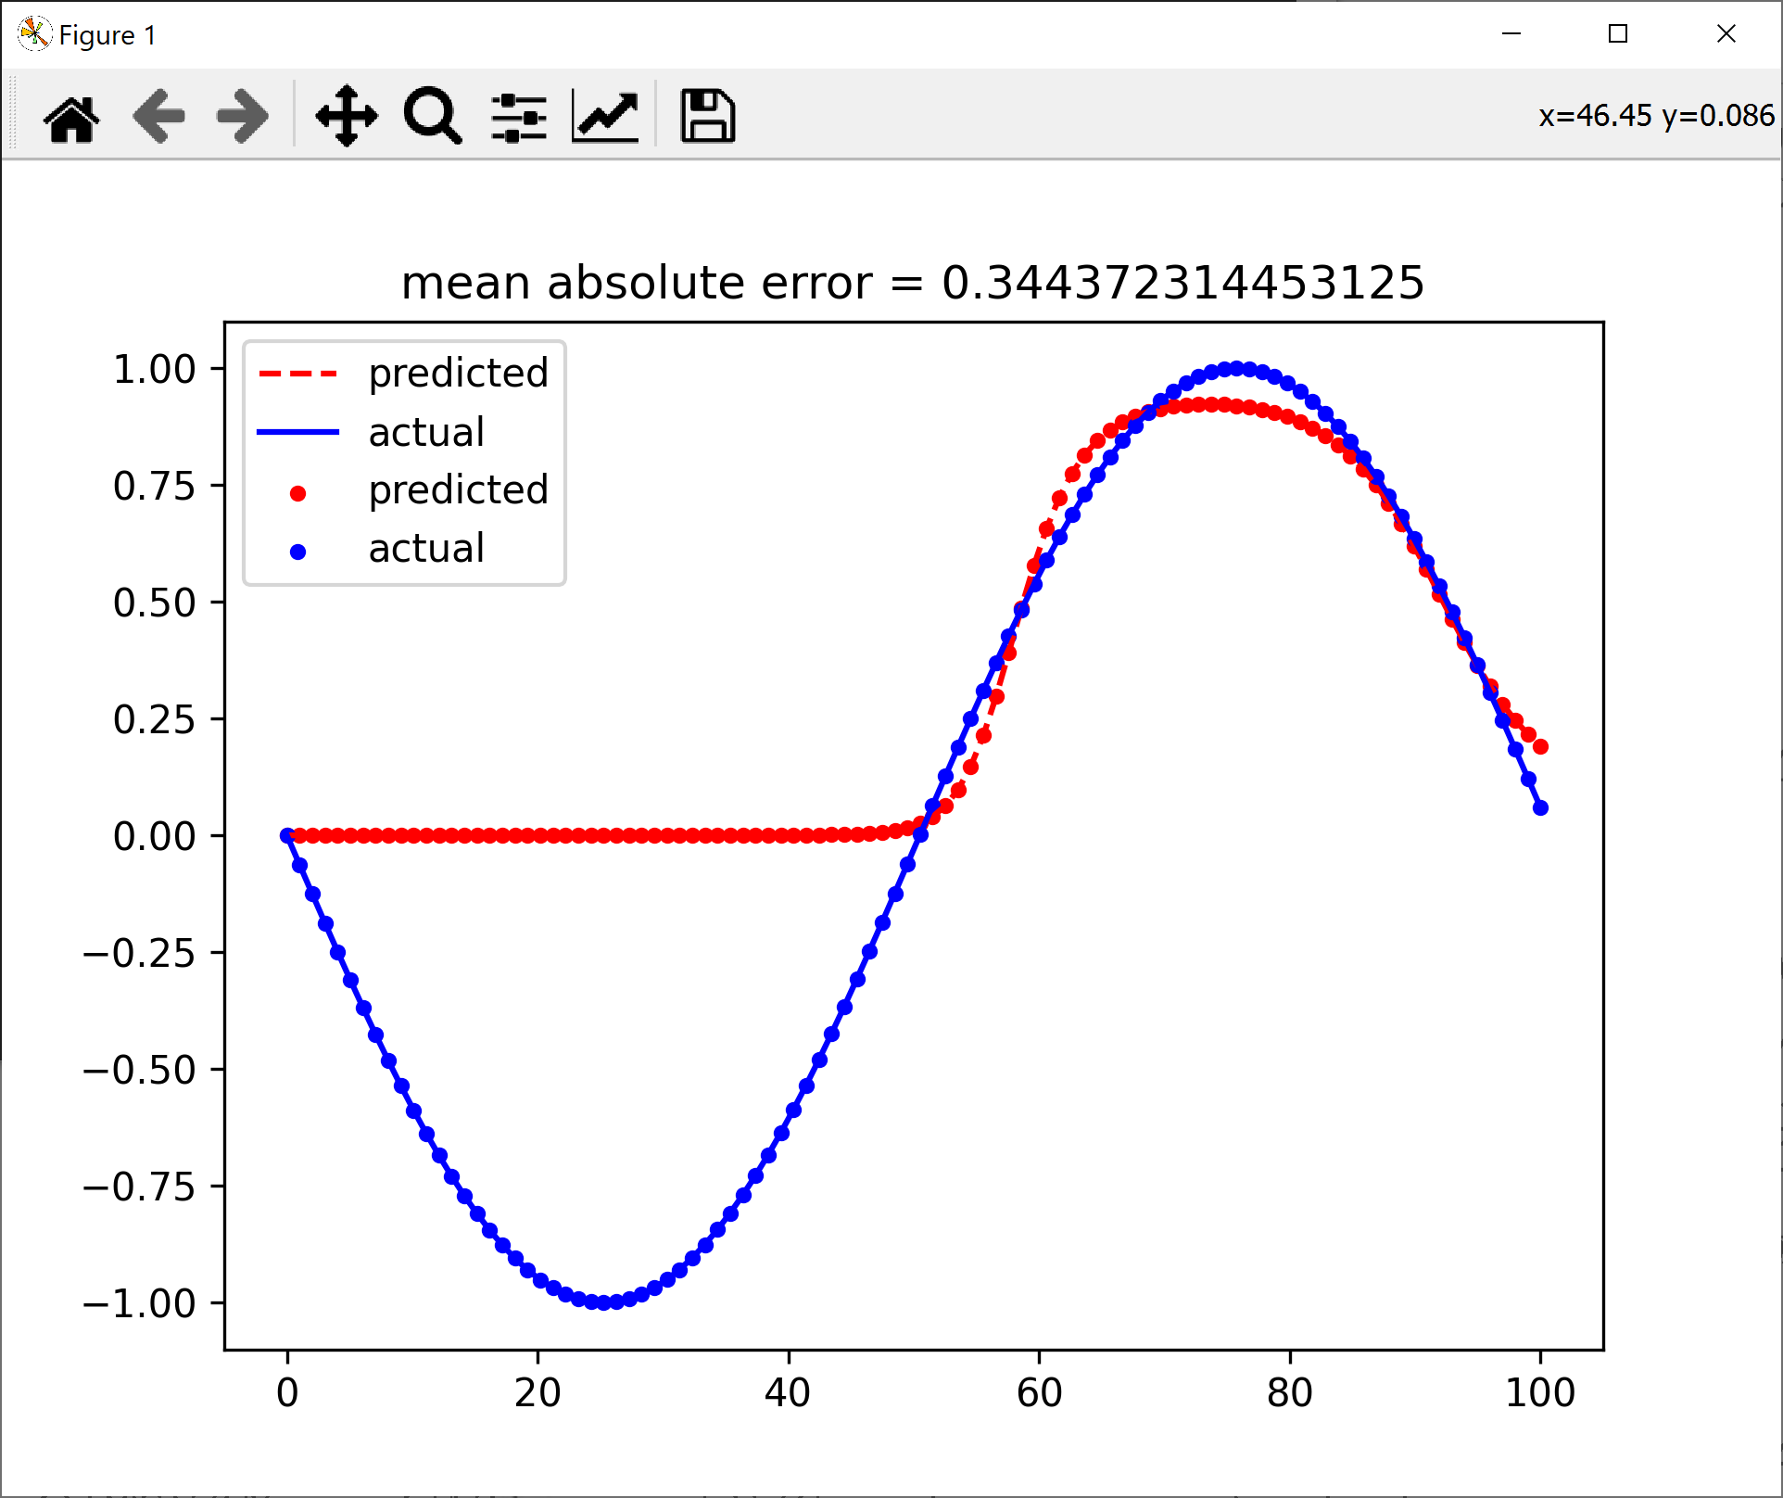
Part 9: Neural Networks and Dataloaders in PyTorch

In this part, you will create a linear network using PyTorch and experiment with using Dataloaders on a custom image dataset.
Step 9.1: In this part we will be working with the Airplanes-Cars-Ships dataset using PyTorch. This dataset contains color images of airplanes, cars and ships. We will create a classifier to classify an image into one of these three categories. The dataset is available as a zip file on BrightSpace. After downloading the zip file, extract it to a folder. It will contain a train and a test folder with three sub folders for images belonging to each category. The number of images in each category for the train and test parts is shown below.

airplanes ships cars
train 1000 1000 1000
test 189 200 193

Step 9.2: Create a Python application called “SimpleClassification”. Add a class to the project called “MyDataSet.py” with the following code in it:

import torch
import torchvision
import numpy as np
import os
from PIL import Image

class MyDataset(torch.utils.data.Dataset):
# for Airplanes, Cars and Ships dataset
# train or test folders further have subfolders containing images
# for each category

def __init__(self, data_dir, transform=None):
self.data_dir = data_dir
self.transform = transform
self.all_image_paths = []
self.all_labels = []

for planecarship_dir in os.listdir(data_dir): # each category folder
category_path = os.path.join(data_dir, planecarship_dir)
if not os.path.isdir(category_path):
continue
if planecarship_dir == "airplanes":
label = 0
elif planecarship_dir == "cars":
label = 1
elif planecarship_dir == "ships":
label = 2
image_paths = [os.path.join(category_path, f) for f in os.listdir(category_path) if f.endswith('.jpg')]
# list of image filenames for a category, e.g., airplane, car, or ship
labels = [label for i in range(len(image_paths))]
self.all_image_paths += image_paths
self.all_labels += labels
self.num_classes = len(set(self.all_labels))

def __len__(self):
return len(self.all_image_paths)

def __getitem__(self, index):
img_path = self.all_image_paths[index]
label = self.all_labels[index]

img = Image.open(img_path).convert('RGB')
if self.transform is not None:
img = self.transform(img)
return img, label

The purpose of the DataSet object is to access the training and test data. If the total training data is small, we can read all the image pixels and store all images in multi-dimensional tensors in the dataset in the computer memory (RAM) directly. However, if the number of images is large and images happen to be relatively high resolution, then one option is to store the image filenames (with full path info) in the dataset. The following code stores all images in the train or test folders as a list of filenames and their labels. It will also apply a transform to the images. Transform usually resizes the image and changes the 0-255 pixel scale to either 0 to 1, or -1 to 1 range.

The __get_item__ function in the DataSet class returns one data item and its label.

Step 9.3: The DataSet is tied to a DataLoader which obtains a batch of data from the dataset and feeds to the training or test loop in the code. Add a file called “Utils.py” to the project with the following code in it:

import torch
from MyDataSet import MyDataset
import torchvision
import matplotlib.pyplot as plt

def get_train_loader(data_dir, batch_size, transform=None):
dataset = MyDataset(data_dir, transform=transform)
data_loader = torch.utils.data.DataLoader(
dataset,
batch_size=batch_size,
shuffle=True,
num_workers=4,
pin_memory=True,
drop_last=True
)
return data_loader

def get_test_loader(data_dir, batch_size, transform=None):
dataset = MyDataset(data_dir, transform=transform)
data_loader = torch.utils.data.DataLoader(
dataset,
batch_size=batch_size,
shuffle=False,
num_workers=4,
pin_memory=True
)
return data_loader

def plot_images(images, labels):
# normalise=True below shifts [-1,1] to [0,1]
img_grid = torchvision.utils.make_grid(images, nrow=4, normalize=True)
np_img = img_grid.numpy().transpose(1,2,0) # pytorch has the order, c,w,h
# to be able to view an image, we need to change the order and
# put it in width, height, color order
plt.imshow(np_img)
plt.show()

Step 9.4: Add a class called “NetworkLinear.py” with the following code in it:

import torch
import torch.nn as nn
import torch.nn.functional as F

class NetworkLinear(nn.Module):
def __init__(self):
super().__init__()
self.fc1 = nn.Linear(3*224*224, 100)
self.fc2 = nn.Linear(100, 3)
self.sm = nn.Softmax(dim=1)

def forward(self, x):
x = x.view(-1, 3*224*224)
x = F.relu(self.fc1(x))
x = self.sm(self.fc2(x)) # softmax activation on final layer
return x

As you can see, the above model uses two linear layers. The first layer matches its input to the input image size i.e., 3x224x224 and has 100 neurons in it. It uses the Relu activation function.

The second layer has 3 neurons in it as we have three categories of images. The input specification of the second layer has to match the output of the first layer e.g., 100 in our example. We will test the difference between using a linear network versus a CNN based network in the next assignment. For this assignment we will only work with standard fully connected feed forward neural networks.

Step 9.5: Type the following code in the main file, “SimpleClassification.py”:

import sys
from torchvision import transforms
import torch
import Utils
import torch.optim as optim
from NetworkLinear import NetworkLinear

def main():
device = torch.device("cuda" if torch.cuda.is_available() else "cpu")
data_dir_train = "D:/DeepLearning2/data/Dataset_PlanesCarsShips/train" #TODO: change to your filepath
data_dir_test = "D:/DeepLearning2/data/Dataset_PlanesCarsShips/test" #TODO: change to your filepath
image_transforms = {
"train": transforms.Compose([
transforms.Resize((224, 224)),
transforms.ToTensor(),
transforms.Normalize([0.5, 0.5, 0.5],
[0.5, 0.5, 0.5])
]),
"test": transforms.Compose([
transforms.Resize((224, 224)),
transforms.ToTensor(),
transforms.Normalize([0.5, 0.5, 0.5],
[0.5, 0.5, 0.5])
])
}
# ToTensor converts a PIL Image or numpy.ndarray (HxWxC) in the range [0, 255]
# to a torch.FloatTensor of shape (CxHxW) in the range [0.0, 1.0]
batch_size = 16

num_epochs = 25
train_loader = Utils.get_train_loader(data_dir_train, batch_size, image_transforms["train"])
test_loader = Utils.get_test_loader(data_dir_test, batch_size, image_transforms["test"])
train_iter = iter(train_loader)
images, labels = next(train_iter) # get a batch of data e.g., 16x3x224x224
print(images[0].shape)

Utils.plot_images(images,labels) # plot images

net = NetworkLinear() # create the simple linear model
#net = NetworkCNN() # create the CNN model
loss_criterion = torch.nn.CrossEntropyLoss()
optimizer = optim.SGD(net.parameters(), lr=0.001, momentum=0.9)

running_loss = 0
print_freq = 100
for epoch in range(num_epochs):
for i, data in enumerate(train_loader):
inputs, labels = data
optimizer.zero_grad()
outputs = net(inputs) # forward pass
loss = loss_criterion(outputs, labels)
loss.backward()
optimizer.step()
running_loss += loss.item()
#if i % print_freq == print_freq-1:
print('epoch:',epoch, i+1, running_loss/print_freq)
running_loss = 0

#-----------compute accuracy on trained model-------------
total = 0 # keeps track of how many images we have processed
correct = 0 # keeps track of how many correct images our net predicts
with torch.no_grad():
for i, data in enumerate(test_loader):
images, labels = data
outputs = net(images)
_, predicted = torch.max(outputs.data, 1)
total += labels.size()[0]
correct += (predicted == labels).sum().item()

print("Accuracy: ", correct/total)

if __name__ == "__main__":
sys.exit(int(main() or 0))

Step 9.6: Study the above code to see how the training and test loops are set up. Where it says “#TODO: change to your filepath” change the file path to where you saved the dataset (you must make this change in two places in the code).

Step 9.7: Run the program, you should get a classification accuracy of about 75% when using the linear network as the classifier:

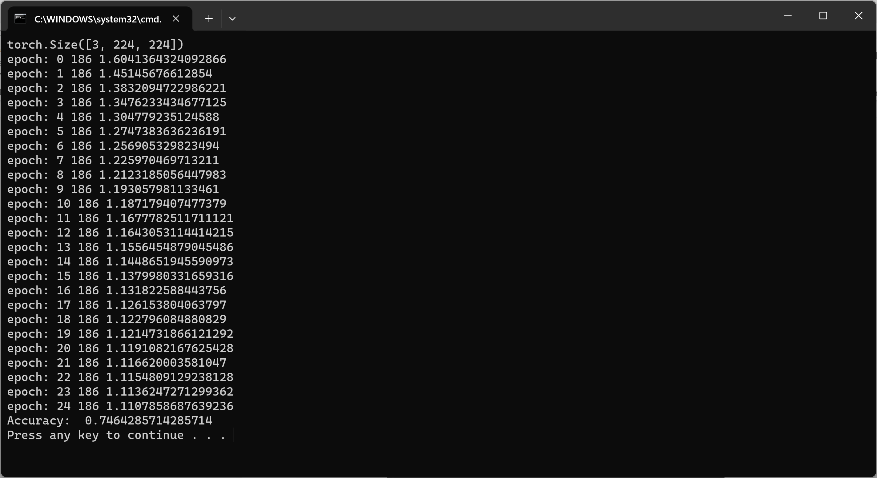

Deliverables

Submit the following two documents on Brightspace:

Deliverable #1: A document that contains screenshot of the output of your code and answers to each of the exercise questions.

Deliverable #2: A copy of your code (the .py files).

